Hiyab Mengisteab
Task 2: Data Processing Solution

Part I: Business Requirements

A. Continuous Monitoring Requirements
To ensure the reliability, efficiency, and compliance of Precision Components Inc.’s data engineering solution, the company requires a continuous monitoring plan. This plan must meet the following business needs:
- Data Reliability: Ensure data is ingested, transformed, and delivered accurately and on schedule (e.g., nightly payroll updates).
- Pipeline Uptime: Identify and resolve ETL pipeline failures quickly to maintain data availability.
- Performance Benchmarks: Track processing times and resource usage to meet SLAs.
- Compliance & Security: Ensure all data handling adheres to industry standards and policies (e.g., payroll data privacy).
- Operational Scalability: As data volume grows with expansion, monitoring must scale and adapt.

Part II: Key Monitoring Components

B. Technologies and Tools for Monitoring AWS Data Pipelines
The following AWS-native tools will be used to monitor the data pipelines:
Tool | Use Case
CloudWatch | Logs, metrics, alarms across all components
Glue Job Metrics | Job-level performance and error monitoring
CloudTrail | Security, compliance, and API call tracking
SNS | Alerting/notifications for issues
Redshift Monitoring | Cluster and query performance
Glue Crawler / Catalog | Schema discovery and metadata issues monitoring

Part III: Continuous Monitoring Plan

C1. Diagram of the Monitoring Components
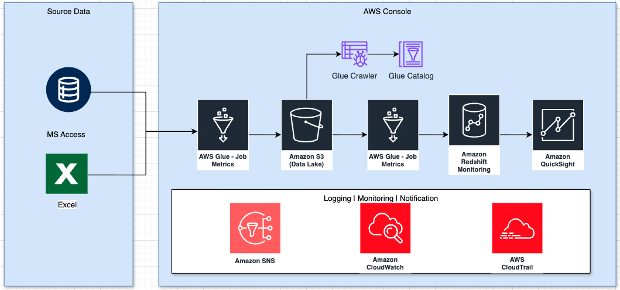

C2. Relation to Business Requirements

Business Requirement | Monitoring Feature
Scheduled Ingestion | Glue job scheduling with CloudWatch Events confirms jobs run nightly.
Data Accuracy | Custom validations in Glue ETL; logs reviewed for transformation errors.
Security/Compliance | CloudTrail tracks access to sensitive data (e.g., payroll).
System Uptime | Alerts via SNS on failed jobs or long runtimes.
Scalability Metrics | CloudWatch tracks throughput and latency over time for forecasting.
Schema & Metadata Integrity | Glue Crawler and Data Catalog monitor schema changes and metadata inconsistencies in the data lake.

C3. Troubleshooting & Business Continuity
The monitoring plan supports quick resolution of issues through:
- Real-Time Alerts: Immediate notification when jobs fail or run slower than benchmarks.
- Historical Logs: Engineers can trace the root cause via Glue logs or Redshift query history.
- Data Quality Checks: Built-in validation steps can flag unexpected nulls, duplicates, or type mismatches.
This ensures that mission-critical data pipelines (like payroll or inventory updates) recover quickly, minimizing business disruption.

Part IV: Summary of Business Benefits

D. Business Benefits of the Monitoring Plan
- Improved Data Trustworthiness
  - Accurate and reliable data delivery ensures leadership can make strategic decisions with confidence.
- Operational Efficiency
  - Early detection of ETL failures reduces downtime, accelerates issue resolution, and minimizes manual intervention.
- Regulatory Compliance and Security
  - Audit logs and alerting help enforce internal controls and demonstrate compliance with data regulations like SOX or GDPR (especially relevant for payroll and HR data).
- Scalability with Confidence
  - Performance metrics allow Precision Components to proactively scale resources before bottlenecks impact performance during growth phases.
- Stakeholder Visibility
  - Dashboards provide both IT and business stakeholders with transparency into system health, reducing dependency on manual reporting.

Reference:
- External resources not used in this submission

